AP Calc AB Name: \_\_\_\_\_\_\_\_\_\_\_\_\_\_\_

\_\_\_\_\_\_\_\_\_\_\_\_\_\_ \_\_\_\_\_\_\_\_\_\_\_\_\_

WS Assessment

Target 24:

Volume with disc / washer method

Revolving around axis

**I can:**

* Calculate the volumes of solids of revolution using the definite integral

Unit 8: Applications of Integration

HW Target 24 Unit 8 Progress Check FRQ

A ***solid of revolution*** is obtained by rotating a plane region about an axis

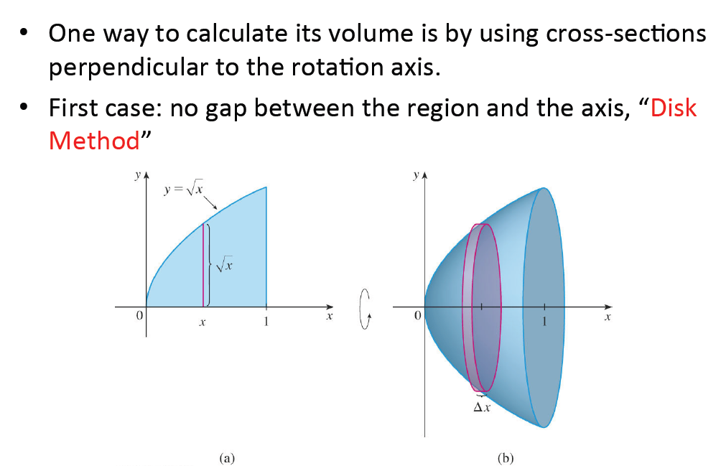

Let R(x) be the radius function in x

* Area of cross-sections now become

A(x) = 2

Determine the volume of the solid obtained by rotating the region bounded by f(x) = ½ x , x = 1, x = 4 and the x-axis about the x-axis. Sketch and name the solid

Determine the volume of the solid obtained by rotating the region bounded by $y=\sqrt{4-x^{2}}$,

and the x-axis about the x-axis. Sketch and name the solid

Determine the volume of the solid obtained by rotating the region bounded by y = x2 – 4x + 5 ,

x = 1, x = 4 and the x-axis about the x-axis. Sketch and name the solid

Sketch and find the volume of the solid that results when the region enclosed by the curves in the first quadrant and is revolved about:

a. x-axis b. y-axis

y = -x2 + 1

Find the volume of the solid that results when the region enclosed by the curves y = x2 + 2;

y = 2x + 2 is revolved about:

a. x-axis b. y-axis

Determine the volume of the solid obtained by rotating the region bounded by

y = x2 – 2x, y = 0 about the line

a. y = 2 b. y = - 2

Determine the volume of the solid obtained by rotating the region bounded by

y = x2 – 2x, y = 3 about the line

a. y = 4 b. y = - 4

Let R be the region between the x axis, the curve y = x3 and the line x = 2. Sketch it.

Sketch and find the volume of the solid obtained by revolving R about

the x-axis the y-axis

**The washer method:** (gap between the region and the axis)

$g(x) \le f(x)$Consider the region $\textit{\textbf{R}}$ between two curves *y* = *f*(*x*) and *y* = *g*(*x*), where we take both *f* and *g* to be non-negative functions, and   , for an interval in *x* from *x* = *a* to *x* = *b*.  
The volume when $\textit{\textbf{R}}$ is rotated about the *x*-axis   
 \begin{displaymath}\int_a^b \pi (f^2(x)) dx - \int_a^b \pi (g^2(x)) dx = \int_a^b
\pi(f^2 - g^2) dx.\end{displaymath}

$y = \sqrt{x}$

Sketch and find the volume by the region $\textit{\textbf{R}}$ between the curves   and *y* = *x*2, when the region $\textit{\textbf{R}}$ rotated about the *x*-axis.

Sketch and find the volume by the region $\textit{\textbf{R}}$ between the curves   and *y* = *x*2, when the region $\textit{\textbf{R}}$ rotated about the line y = 2

Let R be the region in the first quadrant enclosed by the graphs of $y=e^{x^{2}}-1$   and y = 4x.

Find the area of R

Find the volume of solid generated when R revolved about x-axis

Find the volume of solid generated when R revolved about y-axis

Find the volume of solid generated when R revolved about y = -1

Find the volume of solid generated when R revolved about y = 6

Find the volume of solid generated when R revolved about x = -1

Find the volume of solid generated when R revolved about x = 6

Region R form the base of the solid whose cross sections perpendicular to the y-axis are square. Find the volume of this solid

Region R form the base of the solid whose cross sections perpendicular to the y-axis are equilateral trianle. Find the volume of this solid

Region R form the base of the solid whose cross sections perpendicular to the y-axis are semicircle. Find the volume of this solid

**Assessment**

Use the method of disc to derive the formula for the volume of a sphere of radius R

Let R be the region in the first quadrant bounded by the graph of y = sinx, the x-axis, and the vertical line x=1. Sketch and find the volume of revolving about

1. x = you choose b. y = you choose
2. x = you choose d. y = you choose

A 2 cm diameter drill bit is used to drill a cylindrical hole through a sphere of radius 5 cm. What is the volume of the resulting object? Sketch